**Ethanolamides for Ocular Drug Delivery**

1Lasowski, F; 2 Moghaddam, M; +1Sheardown, H

+1McMaster University, Hamilton, Ontario, Canada; 2CSIRO, Sydney, New South Wales, Australia

**Introduction**:

Atropine has been suggested as a pharmacologic agent to retard myopia development in children. Similarly, cyclin-dependent kinase inhibitors, such as roscovitine, have been proposed for the prevention of the ocular cancer retinoblastoma. While topical administration of eye drops remains the most prevalent method of delivering drugs to the eye, significant loss (Gaudana, 2008) and potential systemic side effects necessitates a more effective drug delivery method. Therefore, a transscleral lipid based device is proposed.

Since amphiphiles self assemble in the presence of a polar solvent and are stable against dilution, sustained drug delivery is feasible from the lyotropic liquid crystalline phases of these materials. These materials form five main phases. The first is a fluid lamellar phase, consisting a one-dimensional stack of flat amphiphilic bilayers. The next is an inverse bicontinuous cubic phase, which are further characterized as Pn3m, Im3m and Ia3d depending on their crystallographic space group. These can then transition to a hexagonal phase, which appear as cylinders. Finally, disordered packing leads to a L2 inverse micellar phase.

Two examples of these lipids are oleoyl ethanolamide and linoleoyl ethanolamide (Sagnella, 2010); however, both of these molecules form cubic phases at temperatures that are not ideal for ocular delivery. It is hypothesized that new materials, synthesized as mixtures of these pure lipids, will yield properties more amenable to drug delivery for the anterior and posterior of the eye. Specifically, atropine was examined for delivery to the anterior of the eye as a treatment for myopia and roscovitine was explored for posterior delivery as a chemo-preventative agent for retinoblastoma.

**Materials and Methods:**

The monoethanolamides (oleoyl ethanolamide (OEA) or linoleoyl ethanolamide (LEA)) were prepared by two methods: one, the fatty acid was converted to the acid chloride with oxalyl chloride,  then reacted with ethanol amide; or two, the fatty acid was coupled to ethanolamine using EDC/NHS coupling procedures. The purity of oleoyl ethanolamide (OEA) and linoleoyl ethanolamide (LEA) was determined by HPLC, LC/MS or NMR.

These materials were combined in set ratios after being dissolved in tert-butanol (TBA) to form novel compounds, identified according to the amount of LEA in the mixture. To characterize the materials, differential scanning calorimetry (DSC) was performed to determine the energies and peak temperatures of the endotherms. Water penetration into the amphiphiles was assessed using an inverted optical microscope via polarizing optical microscopy in the presence and absence of cross polarizing lenses. These samples were heated at a maximum rate of 1°C/min and allowed to equilibrate before analysis was completed. Small angle x-ray scattering (SAXS) was used to determine phase assignment and lattice parameters for all materials at various temperatures. Dispersions were created for various mixtures using a homogenizer for 5 minutes or more and stabilized using small amounts of poloxamer-407. The particle sizes were then measured using differential light scattering (DLS).

**Results:**

Initial DSC results demonstrated that the mixture materials transitioned in between the pure OEA and LEA transitions shown in previous work (Sagnella, 2010). As the amount of LEA in the materials increased, the transition temperature decreased to that of pure LEA, shown in Figure 1. Individual samples are shown.

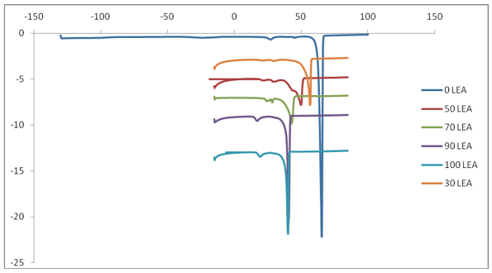

Figure 1. DSC results showing the phase transitions.

Water penetration results showed that polarized phases developed for all materials as water content and temperature increased. Importantly, as the amount of LEA in the material increased, the temperature at which the polarized phases formed decreased. This was consistent with the lower cubic phase transition of LEA compared to OEA. This data was supported by SAXS analysis, performed with 10% and excess water, which showed that cubic phases, specifically Pn3m, formed by 35°C for higher amounts of LEA materials. This is shown in Table 1, where the +/- shows the standard deviation in the lattice size and % represents the liklihood the phase assignment is incorrect. However, by 45°C, the highest amounts of LEA had melted to an L2 state. The presence of therapeutic agents alters the material’s phase transitions.

**Table 1:** Example SAXS phase and lattice parameter analysis

|  |  |  |  |  |  |
| --- | --- | --- | --- | --- | --- |
| **Material** | **Temp. (°C)** | **Cubic Phase** | **Lattice Parameter** | **+/-** | **% Error** |
| 90 LEA | 25 | Pn3m | 10.214 | 0.076 | 0.743 |
| 45 | L2 | 4.431 | - | - |
| 90 LEA, 10% roscovitine | 25 | Pn3m | 7.836 | 0.114 | 1.455 |
| 45 | L2 | 3.716 | - | - |

Dispersions were created for materials fluid at room temperature in excess water, namely those from 60% LEA to 100% LEA. DLS results for these showed the particle size to be around 160-170 nm with a polydispersity (PDI) generally less than 0.22. SAXS revealed the phase of the dispersions to be Im3m, which is different from bulk materials due to the poloxmer-407 stabilizer.

**Discussion:**

Combinations of oleoyl ethanolamide and linoleoyl ethanolamide yield materials with cubic phase transition properties appropriate for ocular drug delivery. These transitions vary according to drug amounts, water content and lipid composition representing a tunable system for therapeutic release.

**References:**

Gaudana R, Jwala J, Boddu SHS, Mitra AK. *Pharm Res,* 2008, **26**(5), 1197.

Sagnella SM et al*. Langmuir*. 2010;26:3084-94.